**Chapter 1**

**INTRODUCTION**

**1.1 OVERVIEW**

In recent years, the Internet of Things (IoT) has changed the world like the Internet did. The IoT has been considered to be one of the most important research topics. The IoT can be defined as billions of passive and active networked devices communicating with each other.

The communication between IoT devices can be achieved anytime and anywhere using services by any links.The IoT is a heterogeneous environment that incorporates many different nodes such as sensors, RFID tags, RFID readers, and mobile devices. In addition, there are many IoT applications in all aspects of our lives, such as military, security, marketing, and healthcare.The IoT is not only a network for data transmission but also can be described as a system containing protocols, events, and big data processing.There are many challenges in the IoT research topics such as data processing and storage, routing, multimedia transmission, security, communication, and energy management.

It is well known that IoT applications often require battery based nodes working for long intervals without human intervention after their initial adaptations. In the absence of energy management methodologies, these nodes would drain their batteries within short periods. In addition, an IoT application can only achieve its mission as long as its nodes are considered alive. Hence, the goal of any energy supply and management technique is to maximize the network lifetime.Therefore, energy consumption is one of the most critical and multidimensional challenges in the IoT environment. This goal is coupled with the single node lifetime. Therefore, energy consumption is one of the most critical and multidimensional challenges in the IoT environment. The IoT nodes that are energy based have different types of applications, such as the wireless sensor network (WSN), radio-frequency identification (RFID) network, and the mobile ad hoc network (MANET).

Unfortunately, most researchers try to design protocols or techniques to minimize the energy consumption rates only for individual or special networks.This cannot be applied to the IoT environment due to its heterogeneous nature.

Consequently finding one technique to minimize the energy consumption rate is difficult. Therefore, in this study, an IoT Energy Management Scheme (EMS) is proposed. This system comprises three main strategies:

The first strategy involves techniques that reduce the amount of data which are transmitted or received by the energy-based nodes. and the second strategy comprises a work methodology to save the energy consumed at each IoT node. and the third strategy comprises a fault tolerance scenario to compensate for failures of energy-based nodes.

The key contributions of this study can be summarized as follows :

• Use of data reduction techniques in the IoT environment.

• Development of a methodology to save the energy of IoT energy-based nodes.

• Design of a fault tolerance scenario for IoT energy-based nodes.

• Construction of a simulation testbed for the IoT environment.

• Presentation and discussion of the simulation results.

**Chapter 2**

**LITERATURE SURVEY**

1. **Lalia Salman, Safa Salman, Saeed Jahangirian, Mehdi Abraham, Fred German, Charlotte Blair and Peter Krenz.“ Energy efficient IoT-based smart home ” (IEEE)-2016.**

In this work, a home model is analyzed to demonstrate an energy efficient IoT based smart home. Several Multiphysics simulations were carried out focusing on the kitchen of the home model. A motion sensor with a surveillance camera was used as part of the home security system. Coupled with the home light and HVAC control systems, the smart system can remotely control the lighting and heating or cooling when an occupant enters or leaves the kitchen.

The main advantages of this paper are it Manages the energy usage as well as, enhances the living experience in modern homes.

The main disadvantages of this paper are It is not adapted for systems that can transmit large numbers of gigabytes.

1. **Tai-yean Ku,Wan-Ki Park and Hoon Choi.“ IoT energy management platform for microgrid” (IEEE)-2017.**

The IoT smart energy management services provide energy efficiency enhancement, energy sharing and trading services through interconnection and integration of energy supply-transfer-utilization energy systems using the Internet of things. For this, this paper shows an IoT energy management platform with an energy big data system.

The main advantages of this paper are It maximizes the efficiency of using surplus electric power produced by forming an electric power network in a certain scale area.and the main disadvantages of this paper is it’s neglecting the fault tolerance issue.

1. **Waleed Ejaz, Muhammad Naeem, Adnan Shahid, Alagan Anpalagan and Minho Jo.“ Efficient energy management for the Internet of Things in smart cities” (IEEE)-2017.**

In this article, a brief overview of energy management and challenges in smart cities. We then provide a unifying framework for energy-efficient optimization and scheduling of IoT-based smart cities. We also discuss the energy harvesting in smart cities, which is a promising solution for extending the lifetime of low-power devices and its related challenges. We detail two case studies. The first one targets energy-efficient scheduling in smart homes, and the second covers wireless power transfer for IoT devices in smart cities. The main advantages of this paper are Proposed system is optimized and scheduled. and It extended the lifetime of low power devices. The main disadvantages of this paper are that the performance analysis of this framework is weak. and It neglects the large quantity of data that may be transmitted in the smart city.

1. **Haithem Chaouch , Abdullah Salih Bayraktar and Celal Çeken “Energy Management in Smart Buildings by Using M2M Communication ”(IEEE)-2019.**

In this paper, a new Heating, ventilation, and air conditioning (HVAC) system is implemented in order to control and monitor the energy consumption of buildings by using fuzzy logic, machine to machine (M2M) communication, and Internet Technologies. The embedded design’s charge is to save energy during peak hours, without affecting the comfort of the occupant and with self-control managing energy with Internet of Things (IoT) technology. The main advantage of this paper is that the results show that the system developed is capable of automatically reducing energy consumption and maintaining a steady comfort level required by the occupants in the building. The main disadvantages of this paper are This work is relatively complicated to use and the occupants may face some serious problems when applying the right setting for the right case.

**Chapter 3**

**METHODOLOGY**

**3.1 THE PROPOSED ENERGY MANAGEMENT SCHEME**

The proposed EMS is designed specifically for the IoT environment. The main objective of the EMS is to consider the energy problem for wholly heterogeneous energy-based nodes in the IoT environment. To achieve this objective, the proposed EMS design should consider many alternative solutions and ideas. This is because the IoT energy-based nodes are different in their nature and specifications. The concept of the EMS is based on the application of three basic strategies. These strategies are: minimizing transmitted data in the IoT environment, scheduling of the processes of energy-based nodes, and providing fault tolerance. The EMS concept is built on the categorization of energy-based nodes into classes depending on their types such that each class comprises a special type of node (i.e., sensors, RFID, and mobiles). The EMS strategies can then be applied to each class. One or more strategies may be applicable for one class depending on its specifications and nature. The sub-sections below discuss each EMS strategy in addition to the general EMS algorithm which defines how the proposed EMS works.

**3.2 DATA MINIMIZATION**

In the IoT environment, there are many relationships that couple the energy issue with data. The data is considered to be one of the foremost factors which consume the nodes’ energy.This is because there are many forms of data processing, such as gathering, processing, and transmission, that contribute to the level of energy consumed in the IoT nodes. Reducing the volume of data in the IoT environment will, of course, have a positive impact on energy usage. The implementation of the data minimization process differs from one energy-based node class to another. Each class has its own functions and data to deal with.Therefore, the process of data minimization in the EMS comprises data prioritization, data compression, and data fitting.The data fitting process can be used for the class which has data transmission and gathering capabilities.

The data prioritization process can be used for classes which have data gathering, processing, and transmission capabilities. The data compression process is used for the class which has data transmission and processing capabilities.

**3.2.1 DATA PRIORITIZATION**

It is important to clarify that, in the case of IoT network congestion problems, the IoT data should be prioritized. The data prioritization method which is used in the EMS is based on queuing theory. The data is prioritized into ‘n’ classes. Each data class will be processed in a different queue. If the data is prioritized into more than two classes, the size of the data, for which its service may be delayed (or neglected), will increase; that, in turn, results in the reduction of the data which will be served, thereby reducing the amount of data that will be transferred through the IoT network. For simplicity, a two-queue model (i.e., n = 2) is used to prioritize the data.Hence, the IoT data are classified into two classes; namely, C1 and C2. The most important IoT data is assigned to C1. The assignment operation depends on the predefined conditions that are required by different types of applications. The less important IoT data is assigned to C2. The C1 data is enqueued to the first queue, which has a high quality of service (QoS) that makes this class of data have a higher service priority. The second queue service for the C2 IoT data has a low priority.

The formula “ P ij = λ i + μ j ” is used, where P ij is the probability of transition from i (birth state) to j (death state).

**3.2.2 DATA FITTING**

The second data minimization method of the EMS is data fitting . As stated above, this technique is used by the energy-based nodes such as sensors which can gather and transmit information. In the data fitting methodology, the data can be abstracted into a small size and sent to the destination. The abstraction process depends on finding relations between the IoT data, so this relation can be sent with some other parameters which help the destination to extract the original data. To describe the data fitting methodology in a simple manner, the sensor state can be taken as an example.

Suppose that each sensor gathers its data and organizes it into a pair (a, b). The data fitting methodology can now be applied to the gathered data pairs. The data fitting methodology has many techniques. In the proposed EMS, the least square technique is applied as a data fitting methodology. In this area, there are two methods, linear and nonlinear . In the linear method, the interval between each data item, which is gathered by the IoT sensors, should be regular. The regular intervals between data are considered as a special situation in the IoT environment. For simplicity, the linear method is applied to the proposed EMS.

The relation between ‘x’ and the n-vector ‘y’ is determined in X ≈ f(y), where the independent variable is represented by ‘y’ and the response variable is represented by ‘X.’ The relationship between ‘X’ and ‘y’ is determined by ‘f’: R n →R. If ‘y’ is a feature vector, and ‘a’ is predictable data, then the approximation of function ‘f’ (f app ) is required. The term ‘‘f app ’’ is determined depending on the sensor data observations. The relationship between ‘f’ and ‘‘f app ’’ is determined by ,

“ f app = θ 1 f 1 (y) + θ 2 f 2 (y) + θ 3 f 3 (y) + . . . . . . θ n f n (y) ”

where ‘n’ is the number of sensors, and θ 1 , θ 2 , and θ 3 are the parameters which are determined depending on the input and output sensor data.

**3.2.3 DATA COMPRESSION**

The third method to minimize the IoT data size is compression. Data compression is used to minimize the energy consumption rates by decreasing the number of bytes which will be transmitted from energy-based nodes to other nodes in the IoT environment. The compression mechanisms are numerous, especially for data sensors. Implementation of these mechanisms in the IoT environment is still under research. It is very difficult to combine one mechanism with another and apply it in an IoT environment. To remedy this challenge, an existing and proven compression mechanism is selected to demonstrate its impact on reducing energy con- sumption without considering the preference between them. In addition, it is not a requirement that the data compression mechanism be implemented only by energy-based nodes, but it can be implemented from other nodes provided that it has an effect on reducing energy consumption rates.

For example, the data compression may be implemented at sensors as well as at sinks and servers. Furthermore, it is true that the greatest burden in the IoT system is the data that is collected by sensors, but also do not forget that the data for other nodes such as mobiles and RFIDs may represent a danger to their energy consumption rates.

**3.3 SCHEDULING**

The second strategy to minimize the energy consumption rates is scheduling. The scheduling in the IoT means that each energy-based node can achieve its function but without a fixed or predetermined time. The proposed scheduling methodology in EMS should consider seven issues. 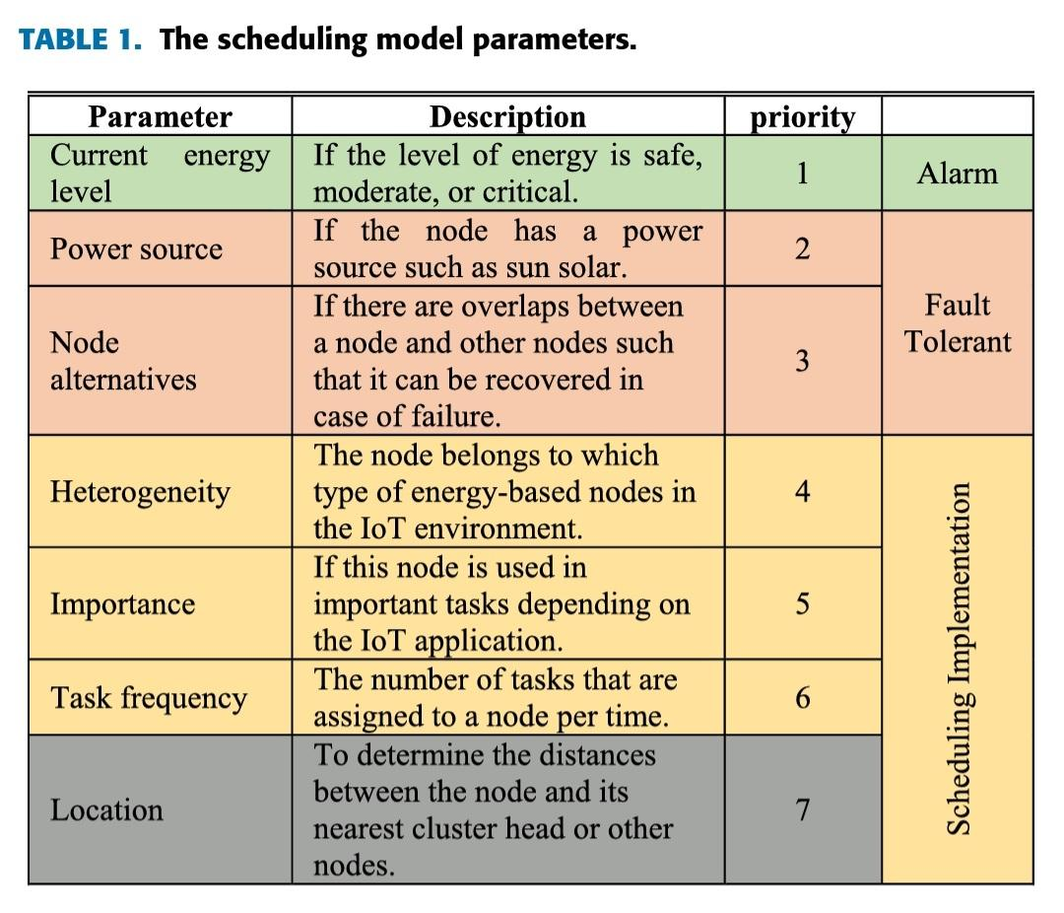

**Fig.3.1** The Scheduling Model Parameters

The first issue is the current energy level at each IoT energy-based node. The second issue is the power source. The third issue is the node alternatives (overlap in covered area). The fourth issue is the heterogeneous energy-based nodes in the IoT system which leads to the heterogeneity in their functions. The fifth issue is the importance of each node. The sixth issue is the frequency of task execution. The seventh issue is the location of each node. These issues determine the relative weight of each node.

These issues may be changed over time. Thus, the scheduling algorithm should work in a dynamic manner. The IoT energy-based nodes are supposed to be classified into groups of clusters for management purposes. Each Cluster has a head which manages its nodes.The scheduling model for sensors is based on the sensor transitioning between three states.The Algorithm 1 and algorithm 2 describe the scheduling models.

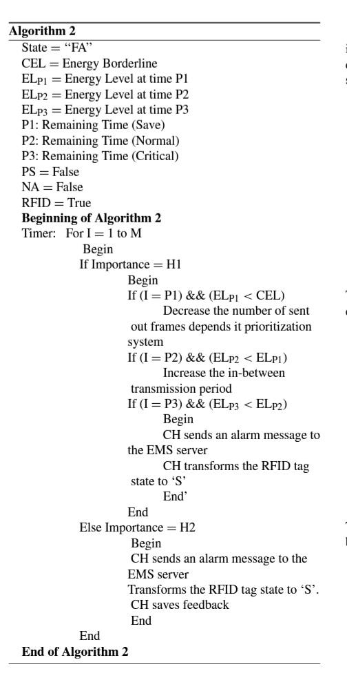

**3.4 FAULT TOLERANCE**

The third strategy used in the EMS is fault tolerance. This strategy is used with or after applying the previous two strategies. In the case of a node’s energy failure, it should be replaced with an alternative node(s).

This strategy is considered as a complement of EMS trying to not lose any data or task in the IoT environment. The fault tolerance strategy depends on the classification of IoT nodes into levels as a function of the importance parameter.

As stated above, the importance parameter is determined based on the nature of tasks that are assigned to the nodes in addition to the locations of the nodes. Therefore, this parameter is well known and predetermined by the IoT administrator(s).

The WSN and RFID cases consist as examples in the fault tolerance strategy because they represent the predominant energy-based nodes in the IoT systems. For the fault tolerance issue in the WSN, there are three types of node recovery process:

**Type 1:** This type is used for nodes that have the highest importance level.

In this type, the coverage process should be achieved using more than one node. The output of the coverage process provides many coverage overlaps; this is called ‘‘Full Overlap.’’In this case, the fault tolerance process may be costly due to the importance of assigned tasks such as for military, security, and terrorism applications.

**Type 2:** This type is used for nodes that have a middle importance level. In this type, the coverage process should be achieved using a number of nodes less than the ‘‘full coverage’’ type. The middle importance level means that the entire task has mid-level importance or part of the task is important and the other part does not have the same importance level.In the case where the total task has a middle importance level, the node coverage process may be partially successful.This type of fault tolerance is called ‘‘Partial Coverage.’’

**Type 3:** This type is used for nodes which have a low importance level. In this type, the coverage process should be achieved using a low number of nodes (i.e. less than the‘‘full coverage’’ and the ‘‘partial coverage’’ types). A low importance level means that the task(s) assigned to the node are not important which leads to low importance of the node coverage area.This type of node can be replaced, its power source can be changed, or it can be neglected. The coverage of this node is considered to be less important. Additionally, to minimize the loss of data, many prediction techniques, such as, may be applied to predict the required data in the case of a node failure.Based on the node’s importance, the fault tolerance mechanism can be applied. In the case of the most important nodes, it can be covered by two or more tags.

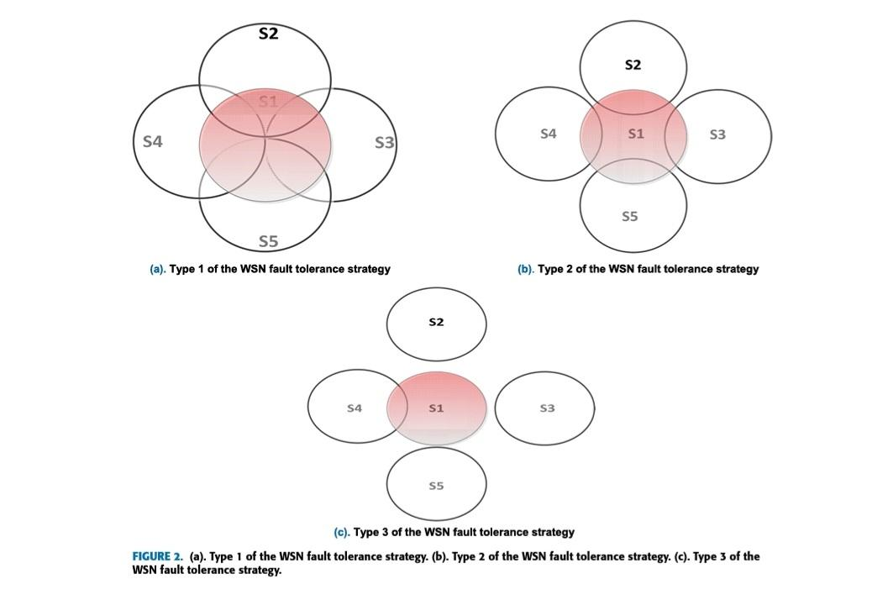

**Fig.3.2** Type1,Type2 and Type3 WSN Fault Tolerance

**Chapter 4**

**SIMULATION AND RESULTS**

In this section, the simulation results of the proposed EMS are shown and discussed. The performance metrics which are used to evaluate the EMS are as follows: the average energy consumption rate for IoT energy-based nodes, the number of failure nodes due to energy loss, the through-put, and the network lifetime. The metrics are measured relative to the IoT traditional system. The traditional system description that is stated in [41] did not apply the EMS strategies. The energy consumption rate is the key performance metric that should be measured in the proposed EMS due to the importance of determining its effect on the IoT system. A low energy consumption rate corresponds to good EMS performance, and vice versa. In the proposed simulation model, WSN, RFID, and MANET are considered as core IoT systems. This is because most of these networks’ nodes are energy-based.

The fig.4.1 shows the results of energy consumption after applying the EMS strategy 1 and the EMS strategies 1 and 2, respectively.

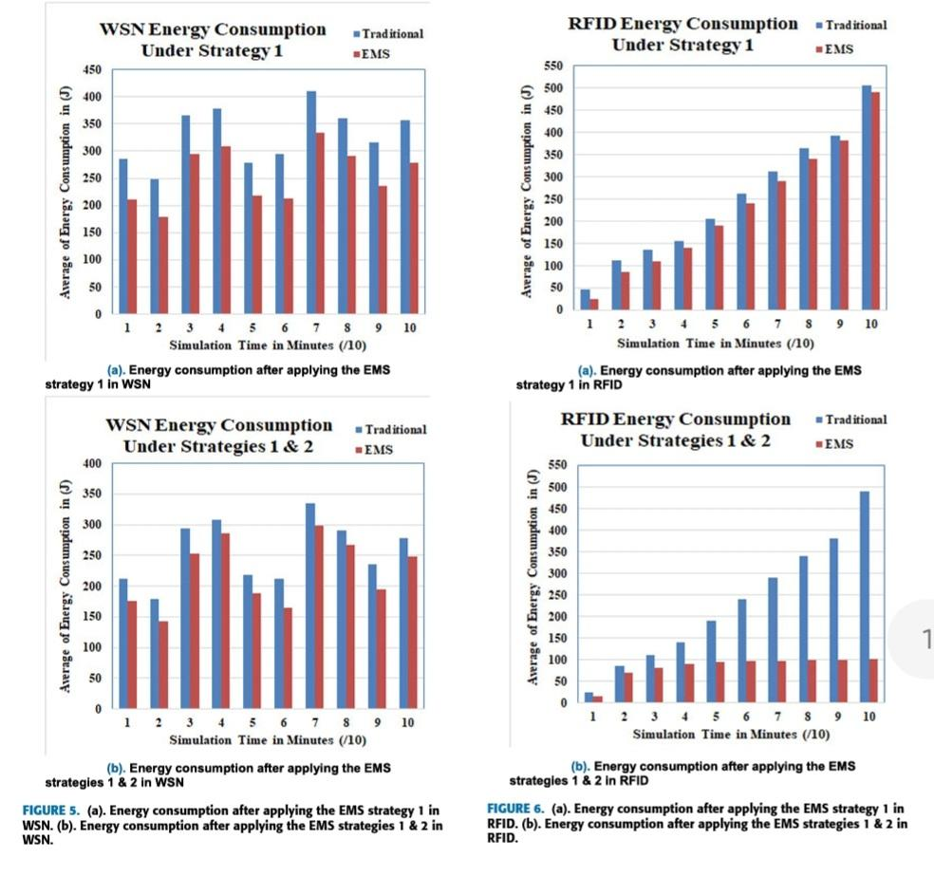

**Fig.4.1(a)(b)** Energy Consumption after applying EMS in WSN and RFID

These figures prove that the EMS also decreases the energy consumption rates. The number of nodes that have failed due to energy loss is a very important parameter due to its effect on many issues in the IoT system such as routing and node functions. Measurement of this performance metric shares in the process of determining the effect of EMS on the entire IoT system. This parameter is measured after applying the EMS strategy 1, strategy 2, and strategy 3. Fig.4.2(a) and (b) show the simulation results for the number of failure nodes metric for WSN, RFID, and MANET, respectively.

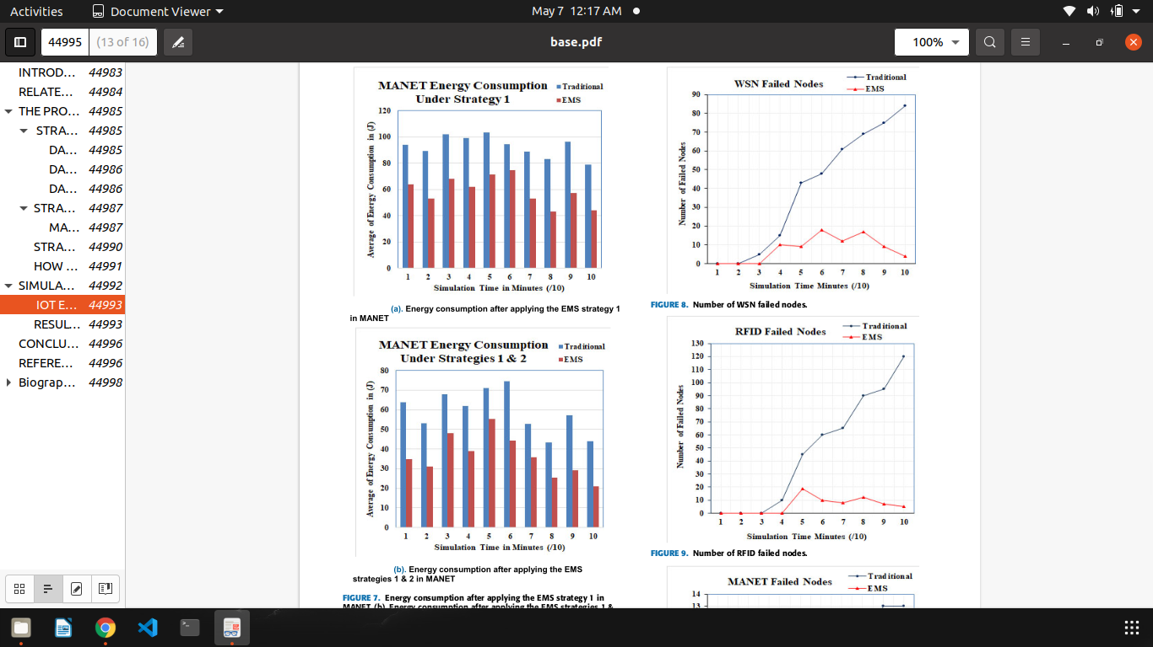

**Fig.4.1(c)** Energy Consumption after applying EMS **Fig.4.2(a)(b)** Number of in failed nodes WSN and RFID

in MANET

On the other hand, the high IoT system lifetime that appears in the EMS means a low number of failure nodes are being compensated, thus decreasing their negative effect.

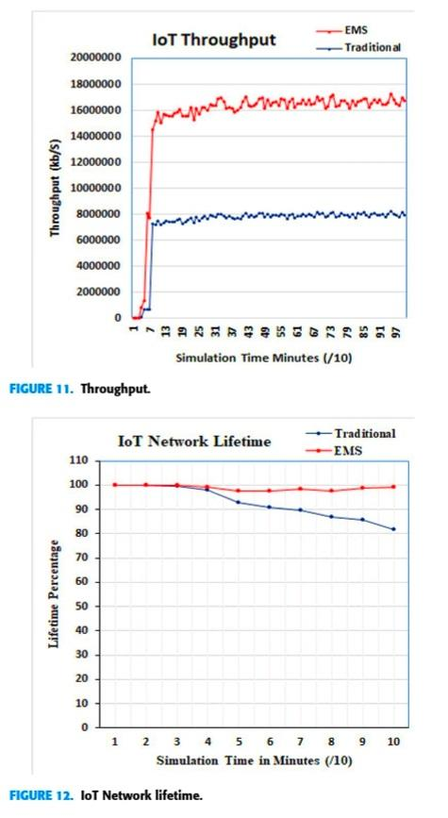 

**Fig.4.3** IoT Throughput **Fig.4.4** Iot Network Lifetime

**Chapter 5**

**CONCLUSION AND FUTURE ENHANCEMENT**

In this study, an Energy Management Scheme for IoT systems was introduced. The basic concept of the EMS is based on application of three different strategies. The first strategy decreased the volume of data which may be transmitted through the IoT system. The second strategy transformed the status of each energy-based node in the IoT system depending on a group of parameters such as energy level importance to save the node energy. The third strategy resolved the fault tolerance issue to find alternative nodes for the ones that have failed due to energy loss.

Finally, the EMS was tested using a simulation environment that was constructed with the NS2 simulator.The simulation results proved that the proposed EMS outperformed the traditional IoT as follows: The energy consumption rate and the number of failure nodes for WSN decreased by 32.66%↓ and 19.75%↓, respectively. The energy consumption rate and the number of failure nodes for RFID decreased by 65.909%↓ and 87.422%↓, respectively.

Finally, the IoT network lifetime is increased by 26.408%↑. Therefore, the EMS is recommended to control the energy consumption rates in the IoT environments.

In future scope, the methods to minimize energy wastage can be further improved and simplified by applying efficient optimization techniques.

**REFERENCES**

[1] J. Wu, M. Dong, K. Ota, J. Li, W. Yang, and M. Wang, ‘‘Fog-Computing Enabled cognitive network function virtualization for an information centric future Internet,’’ IEEE Commun. Mag., vol. 57, no. 7, pp. 48–54, Jul. 2019.

[2] X. Wang, Z. Ning, X. Hu, L. Wang, L. Guo, B. Hu, and X. Wu, ‘‘Future communications and energy management in the Internet of vehicles: Toward intelligent energy-harvesting,’’ IEEE Wireless Commun., vol. 26, no. 6, pp. 87–93, Dec. 2019.

[3] T. Sanislav, S. Zeadally, G. D. Mois, and S. C. Folea, ‘‘Wireless energy harvesting: Empirical results and practical considerations for Internet of Things,’’ J. Netw. Comput. Appl., vol. 121, pp. 149–158, Nov. 2018.

[4] X. Lin, J. Li, J. Wu, H. Liang, and W. Yang, ‘‘Making knowledge tradable in edge-AI enabled IoT: A consortium blockchain-based efficient and incentive approach,’’ IEEE Trans Ind. Informat., vol. 15, no. 12, pp. 6367–6378, Dec. 2019.

[5] G. Li, G. Xu, A. K. Sangaiah, J. Wu, and J. Li, ‘‘EdgeLaaS: Edge learning as a service for knowledge-centric connected healthcare,’’ IEEE Netw., vol. 33, no. 6, pp. 37–43, Nov. 2019.

[6] H. Liang, J. Wu, S. Mumtaz, J. Li, X. Lin, and M. Wen, ‘‘MBID: Micro-blockchain-based geographical dynamic intrusion detection for V2X,’’IEEE Commun. Mag., vol. 57, no. 10, pp.77–83, Oct. 2019.

[7] A. Tolba and A. Altameem, ‘‘A three-tier architecture for securing IoV communications using vehicular dependencies,’’ IEEE Access, vol. 7, pp. 61331–61341, 2019.

[8] Z. Zhou, J. Feng, B. Gu, B. Ai, S. Mumtaz, J. Rodriguez, and M. Guizani, ‘‘When mobile crowd sensing meets UAV: Energy-efficient task assignment and route planning,’’ IEEE Trans. Commun., vol. 66, no. 11, pp. 5526–5538, Nov. 2018.

[9] J. Wu, M. Dong, K. Ota, J. Li, and Z. Guan, ‘‘Big data analysis-based secure cluster management for optimized control planes in software-defined networks,’’ IEEE Trans. Netw. Service Manage., vol. 15, no. 1, pp. 27–38, Mar. 2018.